README: One-Click Install for Windows

Launch The DerbyNet Web Server
After extracting all the files from the downloaded zip file, open the UniServerZ folder, and double-click the UniController application. The UniController window will appear:
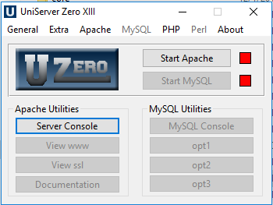
Click on the “Start Apache” button to start the DerbyNet server.
NOTE: If you see a system error box about missing VCRUNTIME140.dll, open the installers folder and run the vc_redist.x86.exe executable (or download a copy from https://www.microsoft.com/en-us/download/details.aspx?id=48145) to install the necessary DLL.
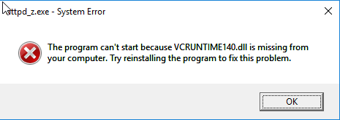

Launch The Timer Interface
To interface to the track timer, double-click derby-timer.jar (next to the UniServerZ folder).
If you see a dialog like this, you need to install Java:
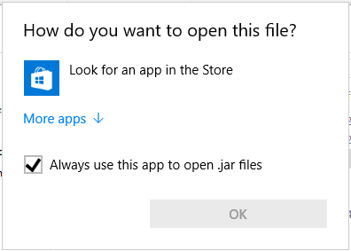
Either download a Java installer from http://java.com for the most recent release, or use the Java installer included in the installers folder.
When derby-timer.jar is successfully launched, its main window will open:
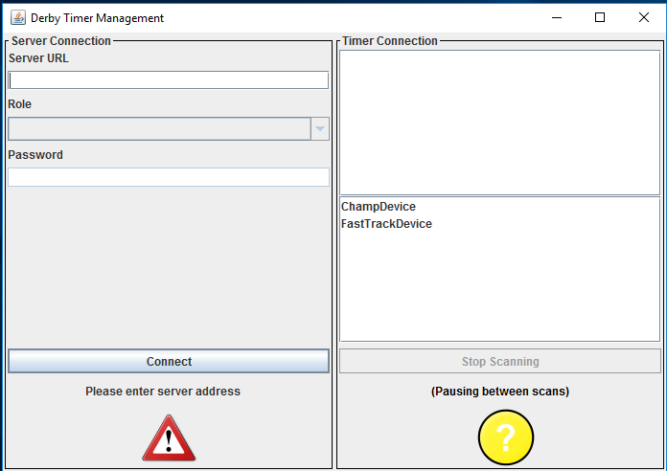
Enter “localhost” as the server URL.

